What is an OTDR?
An OTDR sends a brief pulse of light into a fiber optic cable, and measures the light that is reflected back. That way it can test the whole cable system the same way a submarine uses SONAR to find things in the dark.
The whole process is controlled by a portable computer running Windows CE (Compact Edition), which is a simplified form of Windows XP.

Starting the OTDR
- Turn it on with the button on the lower right of the front panel
- The screen dims a lot to save batteries. When that happens, just touch the screen gently with your fingernail to make it brighten again.
- The starting screen shows the two modules we have installed:

FTB-7300D-23xB-EI-VFL This is the OTDR.

FTB-3932X-5-VFT-EI This is a talk set, a simpler tester, and we won't be using it.

Launching Automatic OTDR Mode
- On the bottom of the screen, there are three buttons:
Advanced OTDR Automatic OTDR Create Ref./Template
- Touch the Automatic OTDR button on the screen with your fingernail or a clean, non-marking stylus, such as the cap from a fountain pen. Don't use the tip of a pen because that will mark up the screen.
- Touch the square Start button in the lower right of the screen.
- An old trace is shown. Ignore it.

Measuring with only the 4.5 km Launch Cord
- Connect the green end of the launch cord to the OTDR, and turn it until it goes in all the way. Make sure the other end is not connected to anything.
- In the Wavelength section, touch 1310 nm and 1625 nm to remove the X signs. Leave the X on 1550 nm.
- Make sure the three dials: Distance (km), Pulse, and Time (s) are all set to Auto.
- Press the Start button in the top right to start.
- When a box pops up saying Main data unsaved…, click No.
- While the trace runs. You will see a yellow box saying Warning! Laser is ON. A Time Remaining counter will count down from 30 to 0.00.

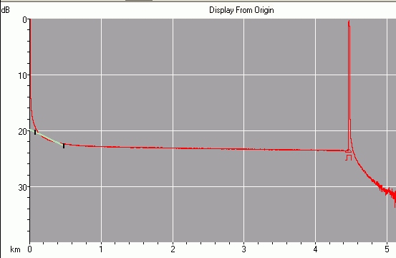
- When the trace is collected, you will see a graph on the screen like the example to the right on this page.
Start of cable
Middle of cable
End of cable
- The horizontal axis is cable length – 0 is the start of the cable, where you plugged it into the OTDR with the green connector. 4.5 km is the other end of the cable.
- The vertical axis is light power.
- The spike in power at zero is reflection from the connector at the start of the cable.
- In the middle of the cable, there is a flat line because there is very little loss as the light goes through it.
- The spike in power at 4.5 km is reflection from the connector at the end of the cable.
- Press the Quick Save button on the upper right part of the screen.
- Click in the File name: box to make an on-screen keyboard appear. Give your trace a file name with your first name in it, and an indication of what you were testing, like YourName 5km Reel.
- Make sure the little box at the lower left of the Save file window says Bellcore – otherwise the file will be saved in a proprietary EXFO format that we cannot use later on the computer.
- Click the Location button. Click the Removable Disk folder. Click the Traces folder. Click OK.
- In the Save file window, click OK. Watch for the green blinking light on the USB memory stick. If the light does not blink, you saved the file into the OTDR instead of on the memory stick – repeat the saving process.
- Click the red X button in the lower right.
Measuring the 66 km. CCSF loop
- Leave the green end of the launch cord connected to the OTDR. Connect the other end to the patch panel on the wall, which goes to the 66 km CCSF fiber loop.
- In the Wavelength section, verify that only the 1550 nm wavelength shows an X.
- Make sure the three dials: Distance (km), Pulse, and Time (s) are all set to Auto.
- Press the Start button in the top right to start.
- While the trace runs. You will see a yellow box saying Warning! Laser is ON. A Time Remaining counter will count down from 30 to 0.00.
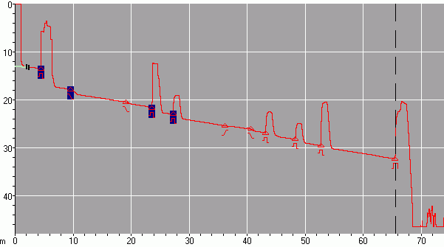
Start of cable
Connection Points
End of cable

- When the trace is collected, you will see a graph on the screen like the one shown above. You will see many events, and the end of the cable plant is now at 66 km.
- Press the Quick Save button on the upper right part of the screen.
- Click in the File name: box to make an on-screen keyboard appear. Give your trace a file name with your first name in it, and an indication of what you were testing, like YourName CCSF Loop.
- Make sure the little box at the lower left of the Save file window says Bellcore – otherwise the file will be saved in a proprietary EXFO format that we cannot use later on the computer.
- Click the Location button. Click the Removable Disk folder. Click the Traces folder. Click OK.
- In the Save file window, click OK. Watch for the green blinking light on the USB memory stick. If the light does not blink, you saved the file into the OTDR instead of on the memory stick – repeat the saving process.
- Click the red X button in the lower right.

