Start Your Vista Machine
- Your host machine should already be started. If it isn't, boot to Vista and log in as Student with no password.

Installing Cain on the Vista Machine
- Click Start, "All Programs", "Mozilla Firefox", "Mozilla Firefox".
- In the Address bar, type www.oxid.it/cain.html and then press the Enter key.
- An OXID.IT web page opens, as shown below on this page. Scroll down and click the "Download Cain & Abel v4.9.15 for Windows NT/2000/XP" link.
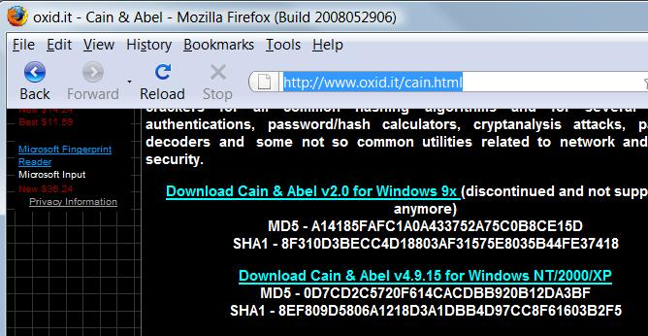

- When the "Opening ca-setup.exe" box appears, click in an empty portion of the box to make the "Save File" button available, and then click the "Save File" button. If a box appears asking you to specify the location of the saved file, select your Desktop.
- On your desktop, double-click the ca-setup.exe file. In the "User Account Control" box, click Allow.
- In the "Cain & Abel v94.9.15 Installation" box, click Next four times, and then click Finish.
- In the "WinPcap Installation" box, click Install. Allow the packet capture program to install, unless it tells you that a more recent packet capture program is already installed.
- When you are prompted to, restart your machine. Log in as Student with no password.

Starting your Windows XP Virtual Machine
- Click Start, "All Programs", VMware, "VMware Player". If you see a message about updates, click Close.
- In the "VMware Player" window, click the Open icon.
- In the "Open Virtual Machine" box, on the left side, click Desktop. Double-click the "Win XP Pro for Hacking" folder to open it. Double-click the "Windows XP Professional.vmx" icon.
- Windows XP starts in the VMware window. If it's not already logged in, click the Student icon to log in. No password is required.

Launching Cain
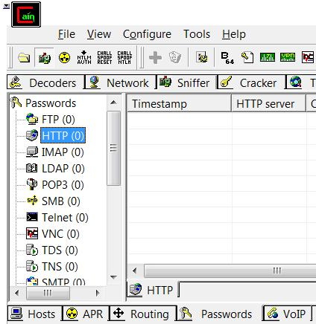
- On the Vista machine's desktop, right-click the Cain icon and click "Run as Administrator". In the "User Account Control" box, click Allow.
- In the upper left of the Cain window, click the second icon (it looks like a little network interface card). That starts the sniffer listening to all traffic.
- In the upper row of tabs, click the Sniffer tab.
- In the lower row of tabs, click the Passwords tab.
- In the left pane, click HTTP.

Logging in to MySpace
- In the Windows XP Virtual Machine, click Start, "All Programs", "Mozilla Firefox", "Mozilla Firefox".
- In the Address bar, type myspace.com and then press the Enter key.
- Type in a fake E-mail address and password and click the "Log in" button. If a box pops up saying "Do you want Firefox to remember this password?", click "Not Now".
- Look at your Vista desktop. The Cain window should show the captured password, as shown below on this page. For this example, I used a username of a@b.com and a password of sillypassword.
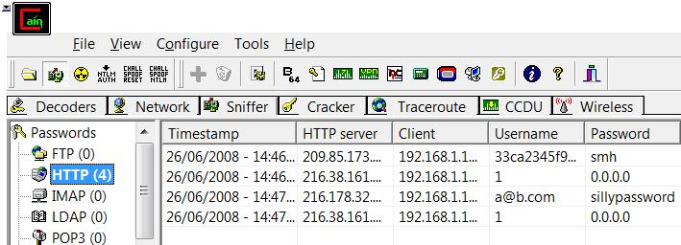

Downloading Ferret and Hamster on the Vista Machine
- On your Vista machine, open Firefox and go to this URL:
http://www.erratasec.com/sidejacking.zip
- Save the file on your desktop. Double-click it to open it. Drag the Sidejacking folder to your desktop.

Running the Ferret Cookie Sniffer on the Attacker Machine
- On the Vista machine's desktop, hold down the Shift key and right-click the Sidejacking folder. In the context menu, click "Open Command Window Here".
- In the Command Prompt window, type the following command, then press the Enter key:
ferret –i 0
- On your Vista machine, open Firefox and go to www.ccsf.edu. You should see a message saying 'Traffic seen proto="HTTP", op="GET", Host="www.ccsf.edu", URL="/"', as shown below on this page.
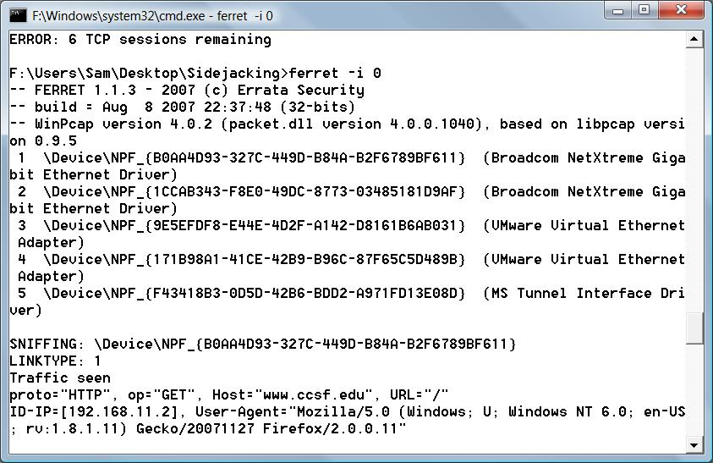
  - If you don't see any traffic, try using a different number after the –i switch to select a different network adapter, such as ferret –i 1

- On the Vista machine, open some web sites, such as google.com and msn.com. You should see information about each website scroll by as Ferret collects cookies.

Running the Hamster Proxy Server on the Attacker Machine
- On the Vista Attacker machine's desktop, double-click Sidejacking folder to open it.
- In the Sidejacking widow, double-click hamster.exe. In the "Open File – Security Warning" box, click Run.
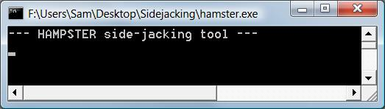
- If a "Windows Security Alert" box pops up, saying "Windows Firewall has blocked some features of this program", click Unblock. In the "User Account Control" box, press Alt+C or click Continue.
- A Command Prompt window opens, showing the message "HAMPSTER side-jacking tool", as shown to the right on this page.

Configuring Firefox to Use the Proxy Server on the Attacker Machine
- On the Vista machine, from the Firefox window's menu bar, click Tools, Options.
- In the Options box, click the Advanced button. Click the Network tab.
- In the Connection section, click the Settings button.
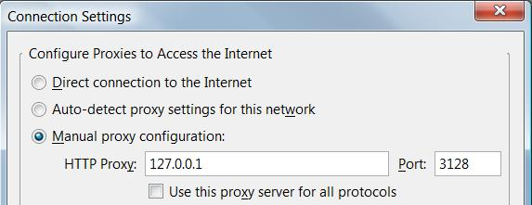
- In the "Connection Settings" box, click the "Manual pro xy configuration" radio button. Enter an HTTP Proxy: of 127.0.0.1 and a Port of 3128, as shown below on this page.
- In the "Connection Settings" box, click OK.
- In the Options box, click OK.

Using the Hamster Web Interface
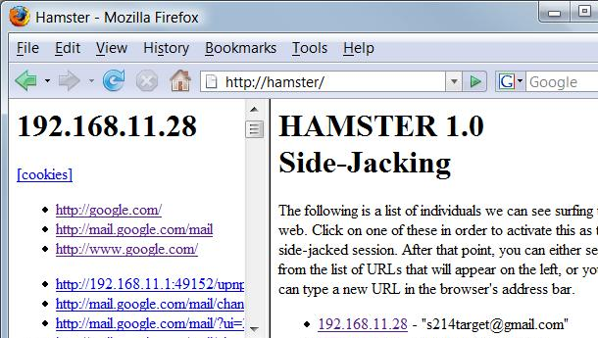
- On the Vista machine, in the Firefox address bar, type in http://hamster and press the Enter key.
- The HAMSTER 1.0 Side-Jacking page should open, as shown to the right on this page.

Opening Gmail on the Windows XP Virtual Machine
- On the Windows XP Virtual machine, in the Firefox window, go to gmail.com
- Log in with a Gmail account. If you don't want to use your own account, use this one: User name S214Target password hackmenow

Viewing the Captured Cookie on the Attacker Machine
- On the Vista Attacker machine, in the Firefox window, click the Refresh button. On the right side, the Gmail account name you used should appear, as shown above on this page.

Viewing Gmail on the Attacker Machine
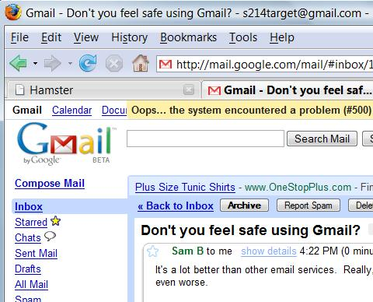
- In the Hamster window, in the right pane, click the IP address next to the gmail address you want to snoop on. In the left pane, click the http://mail.google.com/mail link.
- On the Vista machine, in the Firefox window, a Gmail page opens, as shown to the right on this page. This is the Gmail from the Target machine.
- Click any email in the Inbox to open it.

Trying the Secure Gmail Logon on the Target Machine
- On the Target machine, in the Firefox window showing Gmail, click "Sign out".
- On the Target machine, in the Firefox address bar, type in https://mail.gmail.com and press the Enter key.
- On the Target machine, in the Firefox window, go to https://mail.gmail.com
- Log in with a different Gmail account. If you don't want to use your own account, use this one: User name CNIT124Target password hackmenow

Viewing Gmail on the Attacker Machine
- On the Vista Attacker machine, in the Firefox window, click the Refresh button. On the right side, look at the Target IP address. It appears, but it only shows the previous Gmail account name. The Secure login has protected you!

