
Teaching Hacking

What do Hackers Do?

Get into computer systems without valid accounts and passwords

Open encrypted files without the key

Take over Web servers

Collect passwords from Internet traffic

Take over computers with remote access trojans

And much, much more

Ethical Hackers

Ethical Hackers do the same thing criminal hackers do, with one difference

Ethical Hackers have permission from the owner of the machines to hack in

These "Penetration Tests" reveal security problems so they can be fixed

CNIT 123: Ethical Hacking and Network Defense

Has been taught since Spring 2007 (four times)

Face-to-face and Online sections available Fall 2008

CNIT 124: Advanced Ethical Hacking

Taught for the first time in Spring 2008

Certificate in Network Security
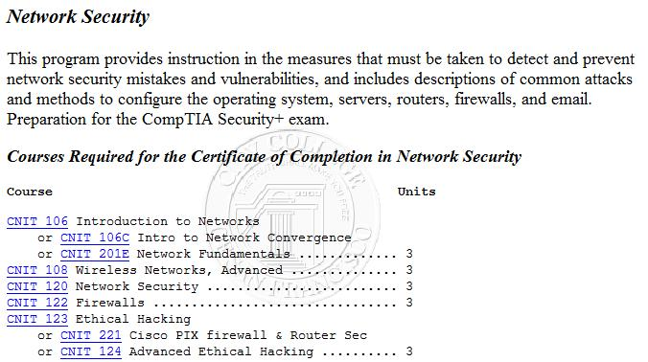

Associate of Science Degree
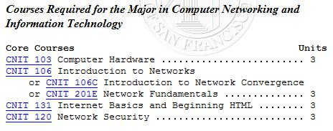

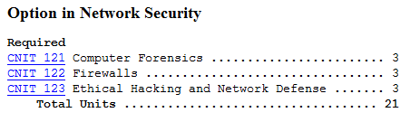

Student Agreement

Required for every student in CNIT 123: Ethical Hacking and Network Defense or CNIT 124: Advanced Ethical Hacking

Student Agreement

CNIT 123: Ethical Hacking and Network Defense

Fall 2008 -- Sam Bowne

I have received and read the Policy Statement for the course shown above, and I agree to enroll in the course under those terms. I understand that the skills I learn here can be dangerous if used improperly, and I agree to use them only in ethical ways. I understand that unauthorized hacking is a crime and could get me into serious legal trouble which neither my instructor nor the college will be able to save me from.

Student’s Name (please print):

Student’s Signature:

Sniffing Plaintext Passwords

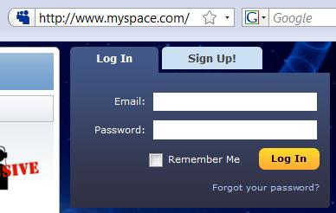
Insecure Login Pages

HTTP does not encrypt data

Always look for HTTPS on login pages

Tool: Cain

Click NIC icon to start sniffer

Click Sniffer tab, Password tab on bottom

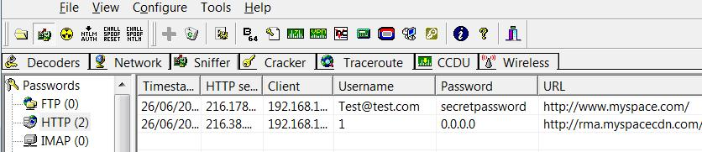
From http://www.oxid.it/cain.html

Authentication Cookies

GMail Uses HTTPS

Sniffing for passwords won't work

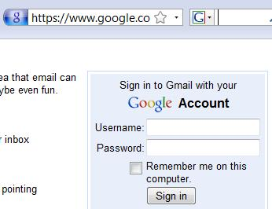
Most Web mail services now use HTTPS too

Cookies

Thousands of people are using Gmail all the time

How can the server know who you are?

It puts a cookie on your machine that identifies you

Gmail's Cookies

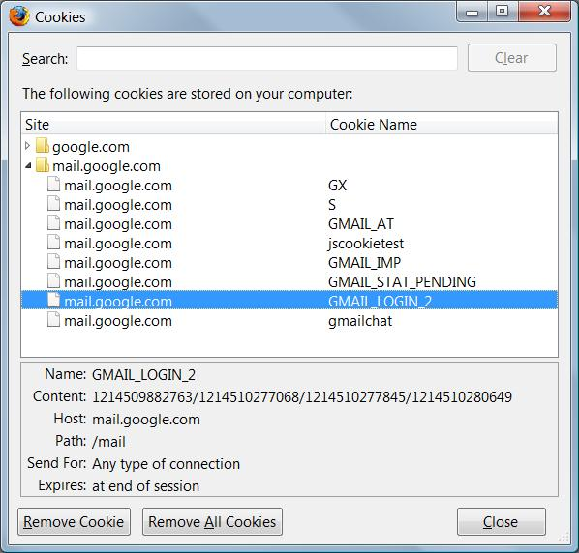
Gmail identifies you with these cookies

In Firefox, Tools, Options, Privacy, Show Cookies

Cross-Site Request Forgery (XSRF)

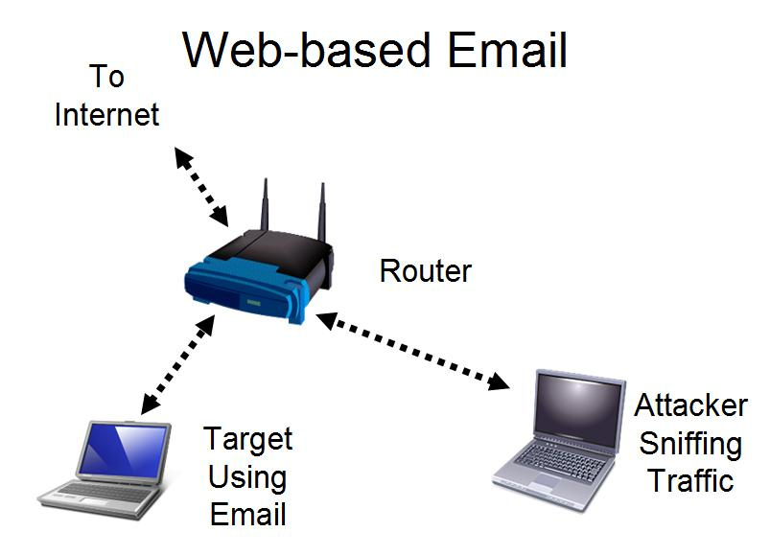
Gmail sends the password through a secure HTTPS connection

That cannot be captured by the attacker

But the cookie identifying the user is sent in the clear—with HTTP

That can easily be captured by the attacker

The attacker gets into your account without learning your password

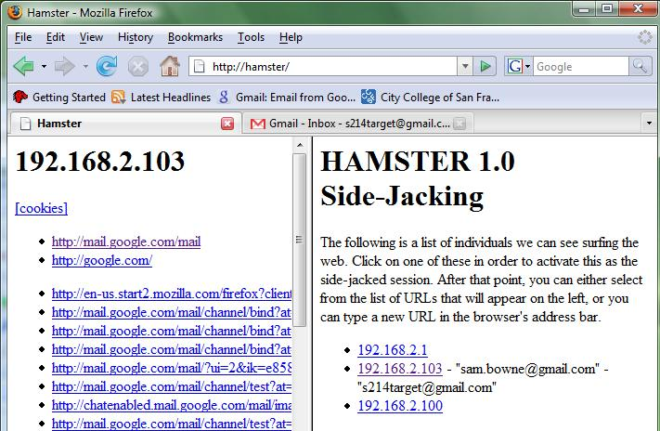
Demonstration

XSRF Countermeasure

Use https://mail.google.com instead of http://gmail.com

No other mail service has this option at all, as far as I know

References

Cain

http://www.oxid.it/cain.html

Hamster

http://erratasec.blogspot.com/2007/08/sidejacking-with-hamster_05.html

Contact

Sam Bowne

Computer Networking and Information Technology

City College San Francisco

Email: sbowne@ccsf.edu

Web: samsclass.info

Last modified 11-6-08

