Sniffing Plaintext Passwords

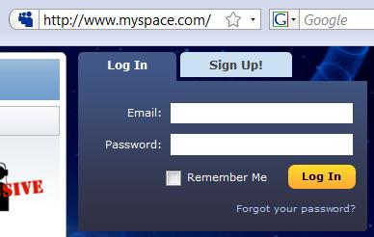
Insecure Login Pages

HTTP does not encrypt data

Always look for HTTPS on login pages

Tool: Cain

Click NIC icon to start sniffer

Click Sniffer tab, Password tab on bottom

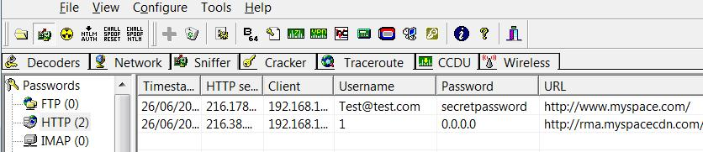
From http://www.oxid.it/cain.html

Authentication Cookies

GMail Uses HTTPS

Sniffing for passwords won't work

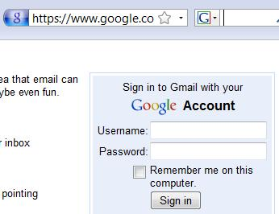
Most Web mail services now use HTTPS too

Cookies

Thousands of people are using Gmail all the time

How can the server know who you are?

It puts a cookie on your machine that identifies you

Gmail's Cookies

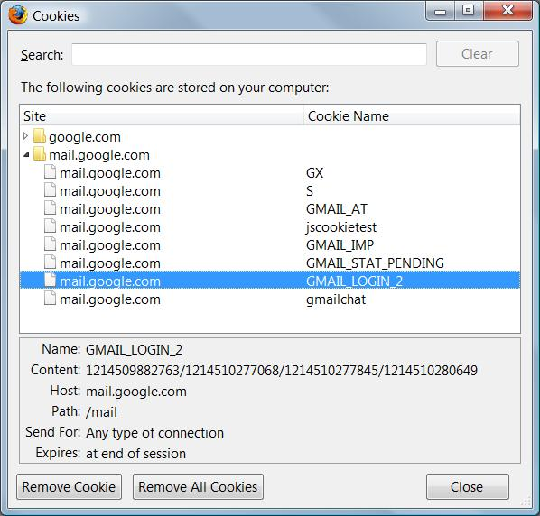
Gmail identifies you with these cookies

In Firefox, Tools, Options, Privacy, Show Cookies

Cross-Site Request Forgery (XSRF)

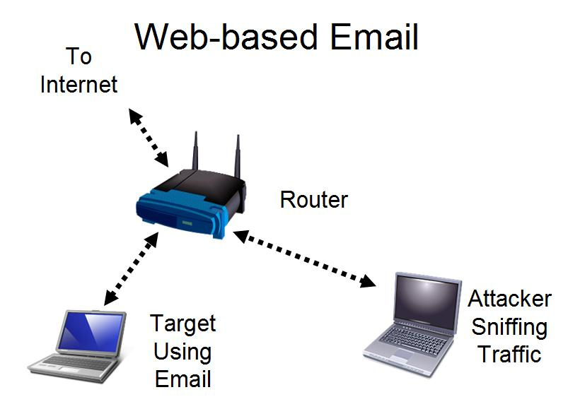
Gmail sends the password through a secure HTTPS connection

That cannot be captured by the attacker

But the cookie identifying the user is sent in the clear—with HTTP

That can easily be captured by the attacker

The attacker gets into your account without learning your password

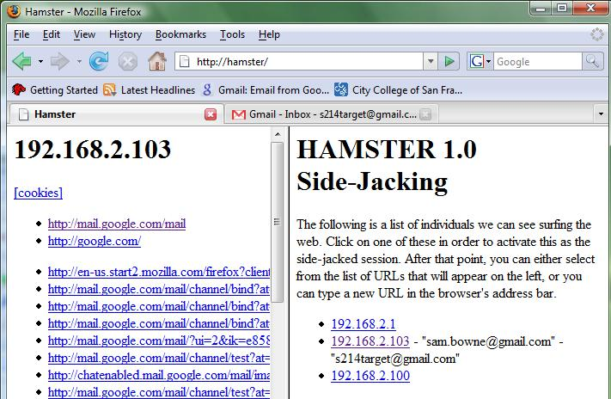
Demonstration

XSRF Countermeasure

Use https://mail.google.com instead of http://gmail.com

No other mail service has this option at all, as far as I know

References

Cain

http://www.oxid.it/cain.html

Hamster

http://erratasec.blogspot.com/2007/08/sidejacking-with-hamster_05.html

Contact

Sam Bowne

Computer Networking and Information Technology

City College San Francisco

Email: sbowne@ccsf.edu

Web: samsclass.info

Last modified 6-26-08

