Sam Bowne
Computer Networking and Information Technology
City College San Francisco
Email: sbowne@ccsf.edu
Web: samsclass.info
Two Hacking Classes



CNIT 123: Ethical Hacking and Network Defense

Has been taught since Spring 2007 (four times)

Face-to-face and Online sections available Fall 2008

CNIT 124: Advanced Ethical Hacking

Taught for the first time in Spring 2008

Supplemental Materials

Projects from recent research

Students get extra credit by attending conferences







Certified Ethical Hacker


Those two classes prepare students for CEH Certification

Certificate in Network Security

Associate of Science Degree

Four Vulnerabilities

SQL Injection

16% of Web sites vulnerable

Cross-Site Scripting

65% of major sites vulnerable

Cross-Site Request Forgery

Almost every Web site with a login is vulnerable

Layer 7 Denial of Service

Every site with active content is vulnerable
SQL Injection

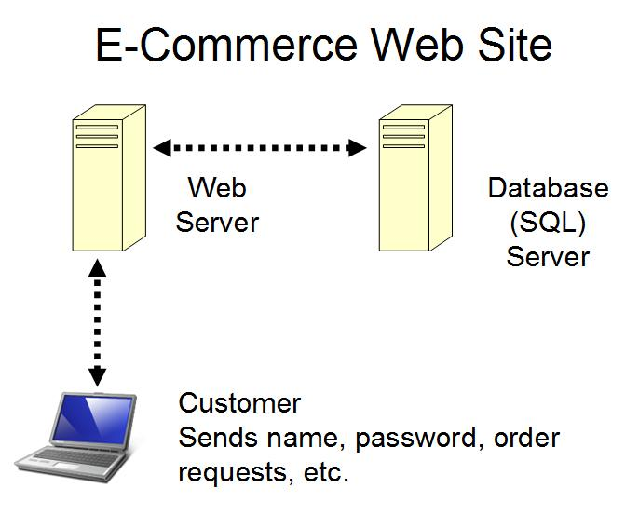

E-Commerce Login

HTML Form collects name and password

It's processed at the SQL server with code lik e this:

SELECT * FROM customer WHERE username = ‘name' AND password = ‘pw'

SQL Injection

If a hacker enters a name of

’ OR 1=1 –

The SQL becomes:

SELECT * FROM customer

WHERE username = ‘’ OR 1=1 --' AND password = ‘pw‘

The -- ends the statement, making the rest of the line a comment

1=1 is always true, so this makes the condition true

Demonstration
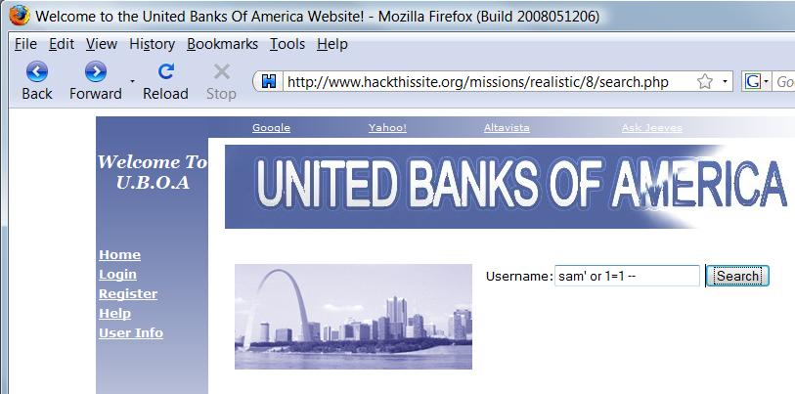

SQL Injection Effects

This can cause the user to be authenticated as administrator, dump the entire database, or have other drastic effects

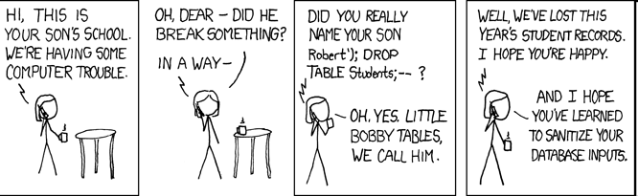

Comic from xkcd.org

Sanitize your Inputs

All user input should be checked, and special characters like ' or '' or < or > discarded

That will reduce vulnerability to SQL injection

The typical SQL Injection vulnerability takes more than four months to locate and fix

Cross-Site Scripting (XSS)

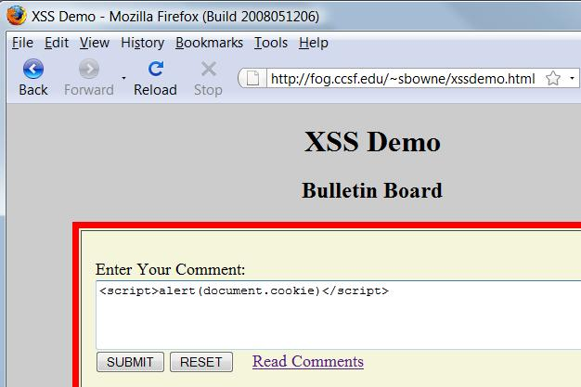
Web Message Board

Cross-Site Scripting (XSS)

One client posts active content, with <script> tags or other programming content

When another client reads the messages, the scripts are executed in his or her browser

One user attacks another user, using the vulnerable Web application as a weapon

Demonstration

<script>alert("XSS vulnerability!")</script>

<script>alert(document.cookie)</script>

<script>window.location=
"http://www.ccsf.edu"</script>

XSS Scripting Effects

Steal another user's authentication cookie

Hijack session

Harvest stored passwords from the target's browser

Take over machine through browser vulnerability

Redirect Webpage

Many, many other evil things…
Cross-Site Request Forgery (XSRF)

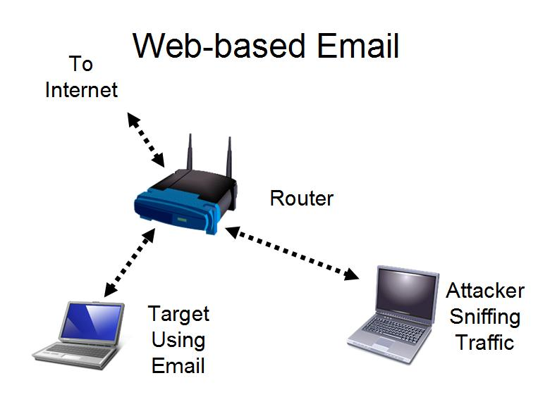
Web-based Email

Cross-Site Request Forgery (XSRF)

Gmail sends the password through a secure HTTPS connection

That cannot be captured by the attacker

But the cookie identifying the user is sent in the clear—with HTTP

That can easily be captured by the attacker

The attacker gets into your account without learning your password

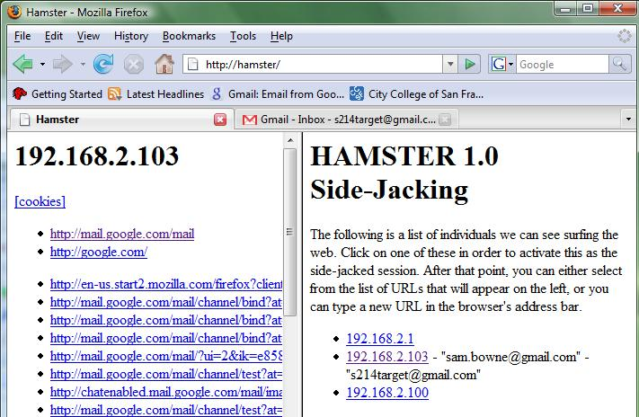

Demonstration

XSRF Countermeasure

Use https://mail.google.com instead of http://gmail.com

No other mail service has this option at all, as far as I know

Application-Layer Denial of Service

Application-Layer DoS

Find small requests that consume a lot of server resources

Application Crashing

Data Destruction

Resource Depletion

Memory

CPU

Bandwidth

Disk Space

Resource Depletion Example

CPU Consumption

On a large forum

Create a complicated regular expression search

Use a script to launch the search over and over

Real-World Test

Hacktics, a security company, brought down a large corporate network with just three laptops in an authorized test

Global company with branches in Israel, Europe and the USA

Internet Connectivity – 3x50Mbps lines with load balancing. ISPs provide Cisco (Riverhead) based Anti DDoS solutions

High security network, 30+ Web servers, backend servers, Mail Relay, databases

Hacktics Results

DoS was successful to all systems but one

Two applications crashed completely after a few dozen requests only

Most other applications stopped responding after 5-15 minutes of script execution from up to three laptops (though with most a single laptop was sufficient)

Main cause of DoS was CPU exhaustion

References

Where the Web is Weak

http://www.forbes.com/2008/05/14/web-hacking-google-tech-security08-cx_ag_0514webhack.html

Application-Layer DDoS Attacks

http://networks.rice.edu/papers/2006-04-Infocom-final.ppt

