Purpose: WOT (Web of Trust) is a Firefox extension that warns you about sites that are known to be dangerous. Sites have a reputation, assigned by other WOT users. This protects you from scams, phishing sites, sites hosting malware, pornography, and other Internet nasties.
Requirements: You need a Windows or MAC computer (any version) connected to the Internet.

Installing WOT
- Open Firefox. If you don't have Firefox, use Internet Explorer (or Safari), go to getfirefox.com, and download it.
- From the Firefox menu bar, click Tools, Add-ons.
- In the Add-ons box, in the search field, type WOT as shown below on this page. Press the Enter key.
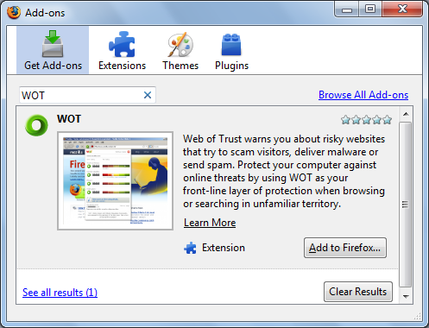

- In the Add-ons box, click the "Add to Firefox…" button.
- In the "Software Installation" box, click the "Install Now" button.
- In the Add-ons box, click the "Restart Firefox" button.
Identifying Risky Websites
- In Firefox, go to google.com
- In the Google page, search for WAREZ
- "Warez" are illegal, modified versions of copyrighted software products. As you might expect, many warez sites are harmful to visit. WOT has flagged many of the search results with little round icons, as shown belown on this page. The red icons indicate dangerous sites, and the green ones indicate safe sites. Hover over an icon to see its detailed rating.
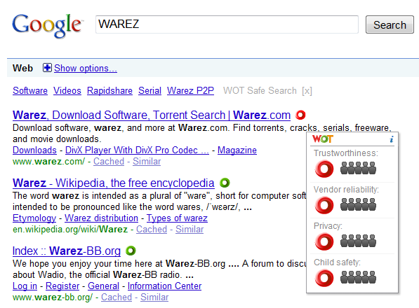

Last modified 12-1-09 8 am

