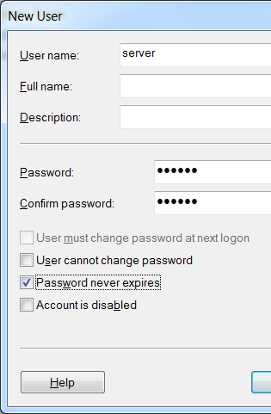
What You Will Need
- Two computers running Windows 7, both connected to a LAN. The "Remote Computer" must be running Windows 7 Professional, Enterprise, or Ultimate.
Selecting Two Machines
- Choose one machone to be the Remote Computer. The other one is the Client.
Creating the Server Account--Do This on the Remote Computer
- On the Remote Computer, click Start, right-click Computer and click Manage.
- In the left pane of Computer Management, expand the "Local Users and Groups" item. Right-click Users and click "New User…".
- In the "New User" box, type server in to the User name, Password, and Conform password boxes. Clear the "User cannot change password" box. Check the "Password never expires" box. Click the Create button. Click the Close button.
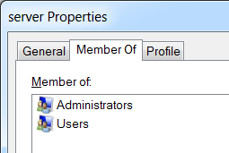
- In the left pane of Computer Management, click Users to select it.
- In the right pane of Computer Management, double-click server. In the "server Properties" box, click the "Member Of" tab. Click the Add… button.
- In the "Select Groups" box, type in Administrators and click OK. The "server Properties" box should now show "Member of:" Administrators, as shown to the right on this page. Click OK.
- Close Computer Management.
Enabling Remote Desktop--Do This on the Remote Computer
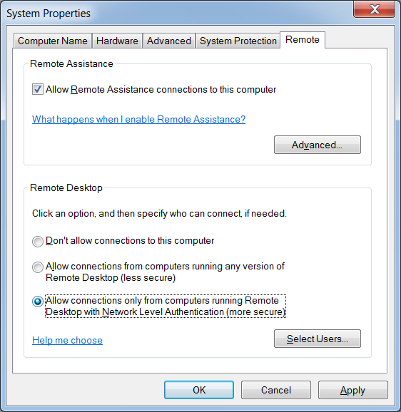
- On the Remote Computer, click Start. Right click Computer and click Properties.
- Click "Advanced system settings".
- In "System Propeties", click the Remote tab.
- In the "Remote Desktop" section, click "Allow connections only from computers running Remote Desktop with Network Level Authentication (more secure)", as shown to the right on this page. If a box pops up warning you about sleep or hibernation, click OK.
- In "System Propeties", click OK.

Finding your IP Address—Do This on the Remote Computer
- On the Remote Computer, click Start, type CMD, and press the Enter key.
- In the Command Prompt window, type the following command, and then press the Enter key:
IPCONFIG
- Scroll up to find your IP Address, as shown below on this page, and write it in the box below on this page. There may be several adapters. In S214, use the one with an IP address starting with 192.168.1.

Server IPv4 Address: ____________________________________

Connecting to the Remote Computer--Do This on the Client
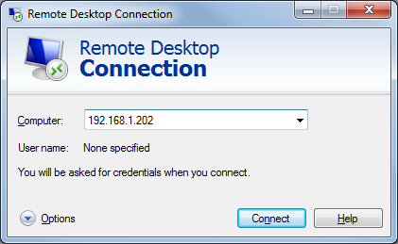
- On the Client machine, click Start and type in REMOTE: Click "Remote Desktop Connection".
- In the "Remote Desktop Connection" box, type in the Remote Computer's IP address, as shown to the right on this page. Click Connect.
- If a box appears asking "Do you want to connect despite these certificate errors?", click Yes.
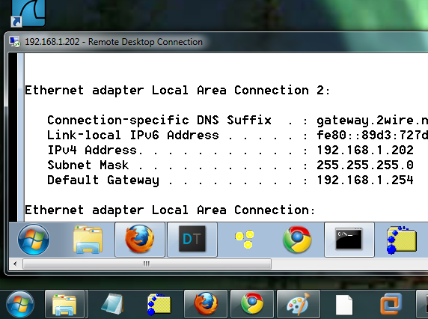
- Log in with a user name of server and a password of server
- A box may appear on the Remote Computer machine's desktop warning you that the user is about to be logged off. If necessary, allow that.
- On the Client, you should see a "Remote Desktop Connection" window with the Remote Computer's desktop inside it, as shown to the right on this page.
Testing Remote Desktop
- Use the Remote Computer from the Client a bit. Open a Web page, try moving and resizing windows, etc. See how it feels--the graphics are more primitive and the response is slower, but it should be usable.

Last modified 1-4-10

