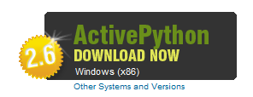
Installing ActivePython
- We’ll use a simple Python application just to see how it uses RAM. Python isn’t installed on Windows by default, so we’ll use ActivePython.
- Open a browser and go to activestate.com/activepython
- Click the “DOWNLOAD NOW” button to get ActivePython 2.6, as shown to the right on this page. Save the installer file.
- Run the installer and install the software with the default options.

Downloading the WasteMemory.py Script
- Open a browser and go to samsclass.info
- Click the “CNIT 345” link. On the next page, click the Projects link.
- On the "Proj 5" line, point to the "WasteMemory.Python Script" link, as shown below on this page. Right-click and save the file on your desktop.
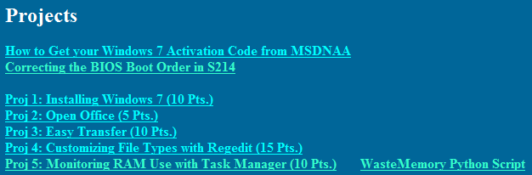
- The file you downloaded was a Zip archive. To extract it, on your desktop, right-click WasteMemory and click "Extract All…". In the "Extract Compressed (Zipped) Folders" box, click Extract.
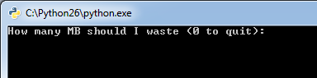
- A window appears with the WasteMemory.py file in it. Double-click the WasteMemory.py file.
- A box pops up asking "How many MB should I waste (0 to quit):", as shown to the right on this page.

Viewing Memory Usage with Resource Monitor
- Click Start. Type in RESOURCE. Find "Resource Monitor" in the results list and click it.
- Resource Monitor opens. Click the Overview tab. Expand the Memory section by clicking the down-arrow on the right side of its line. You should .see an Image named python.exe as shown below on this page.
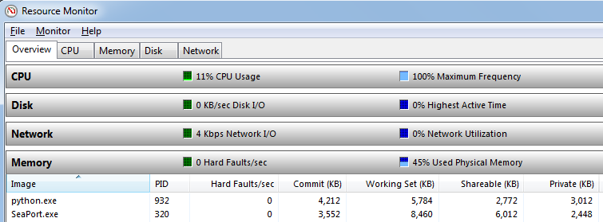

- All the Memory values should be small now. Resize the column headers so you can read them. The value on the right "Private (KB)" should be about 3,000, as shown in the figure above on this page.

Using More RAM
- Find the Python window showing the "How many MB should I waste (0 to quit):" message. Click in that window. Type 50 and then press the Enter key.
- The "Private (KB)" memory usage of the python.exe process should increase to approximately 52,000 K, as shown below.

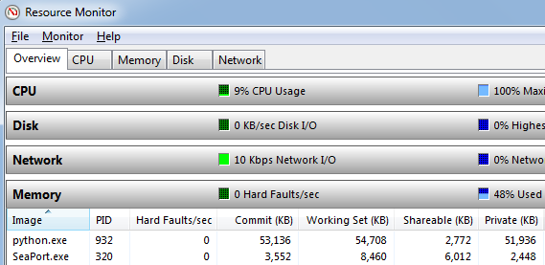

Using Resource Monitor's Memory Tab
- In Resource Monitor , click the Memory tab, as shown below on this page. Look at the bottom section with the colored bar. The right part of the bar, colored blue, shows "Standby" available memory.
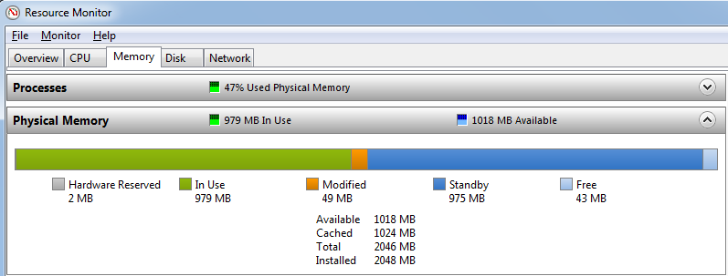

- Find the Python window showing the "How many MB should I waste (0 to quit):" message. Click in that window. Type 1 and then press the Enter key.
- You should be able to see the size of the blue bar change immediately. Try going back and forth from 0 to 50 a couple of times to see how convenient this tool is,

Last revised 1-6-10

