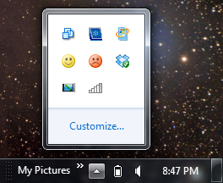
Finding Computers to Use
Up-arrow
Network icon
- You need two Windows 7 computers networked together. Choose one of them to be Computer A and the other to be Computer B.

Moving to a Different Network--Do This on Both Computers A and B
- The Eees you are using are are already in a HomeGroup. To set up your own homegroup, you need to isolate your computers from the others.'
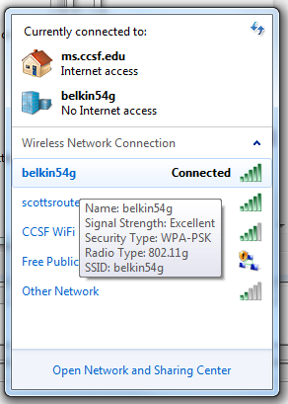
- Move the mouse to the lower right corner of your desktop. Click the Up-arrow, as shown to the right on this page. Click the Network icon, as shown to the right on this page.
- A list of available wireless networks will appear, as shown to the right on this page. Ask your instructor or a lab assistant which wireless network to connect to, so your two machines are the only computers on that network.
- Right-click on your current network and click Disconnect. Then click on the desired network and click Connect.
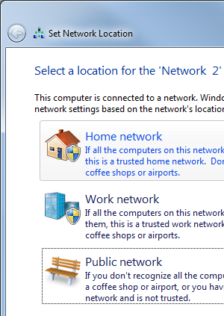

Setting the Network Type to Home--Do This on Both Computers A and B
- A "Set Network Location" box should pop up, as shown to the right on this page. Click "Home network". This is important--HomeGroups are only permitted on Home networks.

Checking HomeGroup Settings--Do This on Both Computers A and B
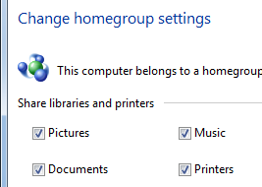
- On Computer A, click Start. Type HOME into the Search box. In the results list, click HomeGroup.
- If you see the message “This computer belongs to a homegroup”, as shown to the right on this page, do this:
  - Click "Leave the homegroup…".
  - Click "Leave the homegroup" again.
  - Click Finish.
- Repeat the process on Computer B.

Verifying That There is No HomeGroup
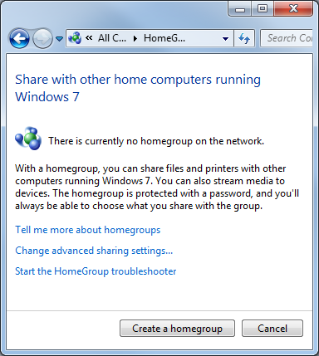
- On Computer A, the HomeGroup box should now show the message "There is currently no homegroup on the network", as shown to the right on this page.

Creating a HomeGroup: Do This on Computer A
- On Computer A, in the HomeGroup box, click the "Create a homegroup" button.
- In the "Create a homegroup" box, click Next.
- A HomeGroup password appears. Write that password below:

Password:
___________________________

Joining a HomeGroup: Do This on Computer B
- On Computer B, the HomeGroup box should show a message saying something like"Student on S214-01 has created a homegroup on the network". Click the "Join now" button.
- In the "Create a homegroup" box, click Next.
- In the next page, type in the password you wrote above on this page. Click Next.
- A message should appear saying "You have joined the Homegroup".

Viewing the HomeGroup: Do This on Computer A
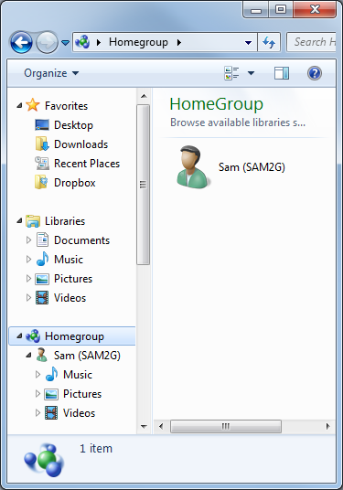
- On Computer A, click Start, Computer. In the left pane, click Homegroup.
- In the right pane, you should see a computer's icon in your HomeGroup, as shown to the right on this page.

Last modified 1-6-10

