Teaching Hacking

Contact

Sam Bowne

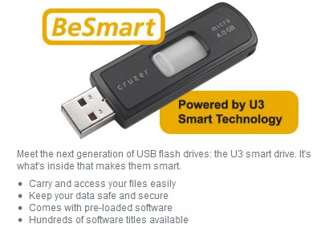
Computer Networking and Information Technology

City College San Francisco

Email: sbowne@ccsf.edu

Web: samsclass.info

Warning!

This is a really dangerous project. You will create a scary, lethal hacking tool and take it home with you.

This tool will steal password hashes in seconds from any Windows computer.

Be careful with it!

Like a handgun, the person most likely to be harmed by it is yourself.
U3 Drives

U3: Software on a Flash Drive

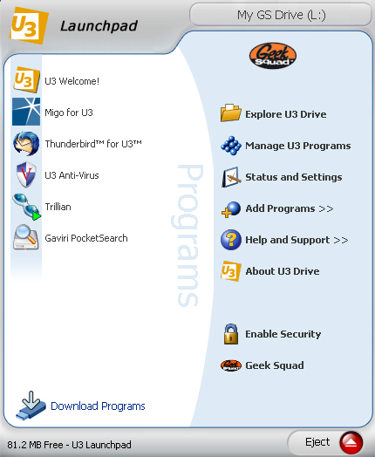
Carry your data and your applications in your pocket!

It’s like a tiny laptop!

U3 Launchpad

Just plug it in, and the Launchpad appears

Run your applications on anyone’s machine

Take all data away with you

How U3 Works

The U3 drive appears as two devices in My Computer

A “Removable Disk”

A hidden CD drive named “U3”

The CD contains software that automatically runs on computers that have Autorun enabled

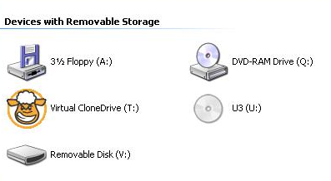
For more details, see http://www.everythingusb.com/u3.html

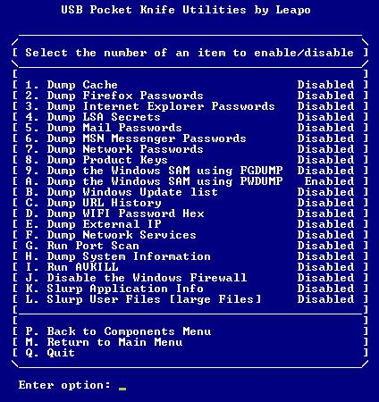
Hak9’s PocketKnife

Software On The Disk Partition

PocketKnife is a suite of powerful hacking tools that lives on the disk partition of the U3 drive

Just like other applications

U3 PocketKnife

Steal passwords

Product keys

Steal files

Kill antivirus software

Turn off the Firewall

And more…

For details see wapurl.co.uk/?719WZ2T

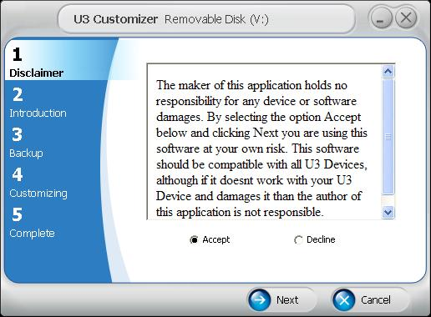
Custom Launchpad

Customizing U3

You can create a custom file to be executed when a U3 drive is plugged in

Automatically Run PocketKnife

The custom U3 launcher runs PocketKnife

So all those things are stolen and put on the flash drive

Defense
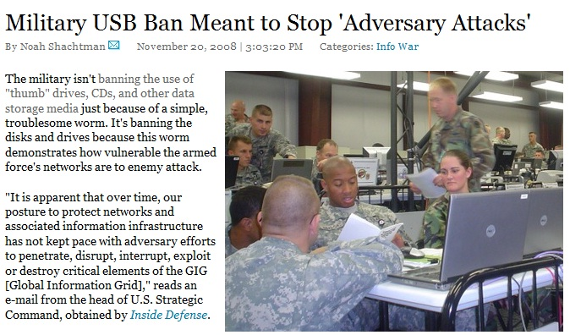

Immediate Risk Reduction

Block all USB devices in Group Policy

Disable AutoRun

Glue USB ports shut

Better Solution: IEEE 1667

Standard Protocol for Authentication in Host Attachments of Transient Storage Devices

USB devices can be signed and authenticates, so only authorized devices are allowed

Will be implemented in Windows 7

See http://wapurl.co.uk/?QXASJBK

