What You Will Need
Warning: Only use this on networks you own. Cracking into networks without permission is a crime—don’t do it!
- A wireless router set for WEP encryption (64-bit). You need to know the WEP key.
- A computer running any OS with any wireless NIC to be the Wireless Client. This computer must be connected to the wireless router, using the WEP key.
- A Hacker Computer computer with a Linksys WUSB54G Wi-Fi card, or another Wi-Fi card that is compatible with the BackTrack 3 live CD operating system
- A Backtrack 3 Live CD

Getting the BackTrack 3 CD
- You need a BackTrack 3 CD. Your instructor handed them out in class. If you are working at home, you download it from
http://www.remote-exploit.org/backtrack.html

Plugging in the USB NIC
- Connect the USB cable from the Linksys WUSB54G ver. 4 NIC.

Booting the Hacker Computer from the BackTrack 3 CD
- Insert the bt3 CD and restart your "Hacker Computer". If it won't boot from the CD, press F2 to enter the BIOS settings page and set it to boot from the CD. If it asks for a BIOS Password, press the Enter key.
- You should see a message beginning ISOLONUX. At the boot: prompt, press the Enter key. Several pages of text scroll by as Linux boots.
- When you see a page with a bt login: prompt, type in this username and press the Enter key:
root
- At the Password: prompt, type in this password and press the Enter key:
toor
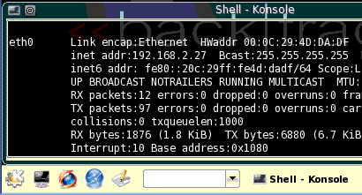
- At the bt ~ # prompt, type in this command and press the Enter key:
Konsole
button
xconf
- At the bt ~ # prompt, type in this command and press the Enter key:
startx
- A graphical desktop should appear, with a start button showing the letter K on a gear in the lower left, as shown to the right on this page.

Starting the Wireless Network Interface Card
- In the "Shell – Konsole" window, type in this command, and then press the Enter key:
airmon-ng start rausb0
This starts the wireless interface with the special MadWiFi drivers, which are necessary for cracking WEP. Now the card is monitoring on all channels.

Capturing Packets to View the Available Networks
- Click the Konsole button to open a new Konsole window, titled "Shell – Konsole <2>".
- In the "Shell – Konsole <2>" window, type in this command, and then press the Enter key:
airodump-ng –w test rausb0
- This command opens a window showing all local networks, as shown below on this page. The captured packets are going to a file named test, which isn't important right now. The columns in the output are explained below:
BSSID The MAC address of the access point
PWR Power level
Beacons The number of beacon packets captured
#Data The number of packets containing Initialization Vectors (IVs) – these are the packets we need to crack WEP.
CH The channel (1 through 11 are used in the USA)
MB The speed of the network in Mbps
ENC, CIPHER, AUTH These values specify the encryption method
ESSID The name of the network

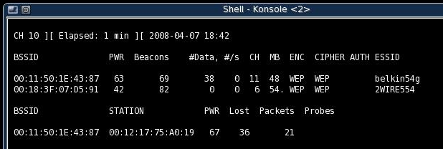
- Write the BSSID, CH, and ESSID of the access point you want to crack into in the box to the right on this page. Note that the BSSID, STATION, etc. information at the bottom of the screen refers to the client, not the Access Point.

BSSID: ______________________________________

CH: __________

ESSID: ______________________________________

- Press Ctrl+C to stop the Airodump capture. If it won't stop, use the mouse to close the "Shell – Konsole <2>" window. Then click the Konsole button to open a new "Shell – Konsole <2>" window.

Restarting Monitoring on the Correct Channel
- Click the "Shell – Konsole" window to make it active—this is the window you used for the airmon-ng commands.
- In the "Shell – Konsole" window, type in this command, and then press the Enter key:
airmon-ng stop rausb0
- In the "Shell – Konsole" window, type in this command, and then press the Enter key:
airmon-ng start rausb0 11
Replace 11 with the CH number you wrote in the box above on this page. Now the card is monitoring only the channel we are interested in.

Resuming Packet Capture
- Click the "Shell – Konsole <2>" window to make it active—this is the Konsole window you used for the airodump-ng command.
- In the "Shell – Konsole <2>" window, type in this command, and then press the Enter key:
airodump-ng –c 11 –w output --bssid 00:11:50:1E:43:87 rausb0
Replace 11 with the CH number you wrote in the box on the previous page of these instructions. Replace 00:11:50:1E:43:87 with the BSSID value you wrote in the box on the previous page of these instructions. Now the card is monitoring only the channel we are interested in. This captures packets on the desired channel, and from the target router, and dumps into the file output.cap. Notice that the #Data are not rising quickly—you may not even see any data being captured at all. Leave this capture running.

Performing a Fake Authorization Attack
- We will send out packets asking to authorize to the access point as a client.
- Click the "Shell – Konsole" window to make it active—this is the window you used for the airmon-ng commands.

- In the "Shell – Konsole" window, type in this command, and then press the Enter key:
aireplay-ng -1 0 –e belkin54g –a 00:11:50:1E:43:87 –h 11:22:33:44:55:66 rausb0
Replace belkin54g with the ESSID you wrote in the box on a previous page of these instructions.
Replace 00:11:50:1E:43:87 with the BSSID you wrote in the box on a previous page of these instructions (the access point's hardware address).
Leave the 11:22:33:44:55:66 value just as it is—this is a fake MAC address we are using to make the fake authorization.
You should see an "Association successful" message, as shown below on this page.
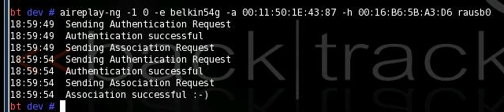

Performing an ARP Replay Attack
- Now we will capture an ARP request, and replay it to force the Access Point to pump out a lot of IVs.
- In the "Shell – Konsole" window, type in this command, and then press the Enter key:
aireplay-ng -3 –b 00:11:50:1E:43:87 –h 11:22:33:44:55:66 rausb0
Replace 00:11:50:1E:43:87 with the BSSID you wrote in the box on a previous page of these instructions (the access point's hardware address).
- The last line in your "Shell – Konsole" window should show the number of packets read, the number of ARP requests captured, and the number of packets sent, as shown below on this page. Within a few seconds, all three of these numbers should start rising rapidly. That means the ARP replay attack is successfully pumping IV values out of the access point, gathering data that can be used to crack the WEP encryption quickly.
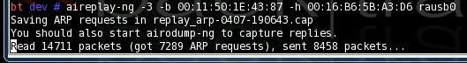

- Look at the "Shell – Konsole <2>" window. The # Data value should be rising very rapidly, as shown below on this page. If it is not, see "Cheating: Creating a Lot of Traffic on Your WLAN" on a later page of these instructions.
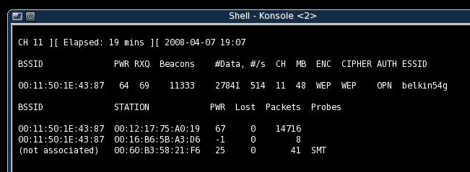

Cracking the Key
- Click the Konsole button to open a new Konsole window, titled "Shell – Konsole <3>".
- In the "Shell – Konsole <3>" window, type in this command, and then press the Enter key:
aircrack-ng –a 1 –n 64 output*.cap
It should find the key within a few minutes, as shown below on this page.
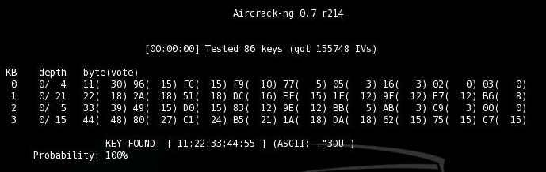

Cheating: Creating a Lot of Traffic on Your WLAN
- If the Packet Injection fails, which it often does, you can cheat by just making a lot of traffic on the LAN. This is a less exciting attack, but a less obvious one—you just listen to the traffic and wait for enough IVs to add up.
- On the Wireless Client, in the Command Prompt window, type in this command and press the Enter key.

Wireless Default Gateway: ____________________________
IPCONFIG
Find “Ethernet adapter Wireless network connection” on the list, and find the “Default Gateway”. Write that number in the box to the above on this page.
- On the Wireless Client, in the Command Prompt window, type in this command and press the Enter key.
ping Gateway –t –l 655
Note that the second switch is a lowercase L, not the numeral 1. Replace Gateway with the “Wireless Default Gateway” you wrote in the box above. This command will send large PING packets (655 bytes each) to the default gateway. You should see replies. Press Ctrl+C to stop the pinging.
- On the Wireless Client, in the Command Prompt window, type in this command and press the Enter key.
ping Gateway –t –l 65500
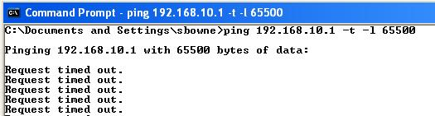
Replace Gateway with the “Wireless Default Gateway” you wrote in the box above. This command will send very large PING packets (65500 bytes each) to the default gateway. You may see “Request timed out” messages, as shown to the right on this page—that's OK. The packets are arriving, but it is taking the router too long to respond.
- On the Wireless Client, click Start, All Programs, Accessories, Command Prompt. Type in this command and press the Enter key.
ping Gateway –t –l 65500
Replace Gateway with the “Wireless Default Gateway” you wrote in the box above. This will start a second window sending traffic to the router.
- Repeat the process 28 more times, until you have 30 Command Prompt windows open, all sending very large PINGs to the router. Your taskbar should show 30 command prompt windows open, as shown to the right on this page. .

Credits
I got a lot of this from "Wireless Vulnerabilities and Cracking with the Aircrack Suite", by Stephen Argent, in the magazine hakin9, Issue 1/2008. There is a lot more information about cracking WEP and WPA in that article, it's great!

Last modified 1-7-09

