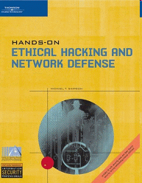
Teaching Hacking

Contact

Sam Bowne

Computer Networking and Information Technology

City College San Francisco

Email: sbowne@ccsf.edu

Web: samsclass.info

CNIT 123: Ethical Hacking and Network Defense

Has been taught since Spring 2007 (four times)

Face-to-face and Online sections available Fall 2008

CNIT 124: Advanced Ethical Hacking

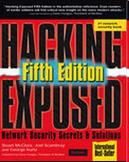
Taught for the first time in Spring 2008

Certified Ethical Hacker

Those two classes prepare students for CEH Certification

Certificate in Network Security

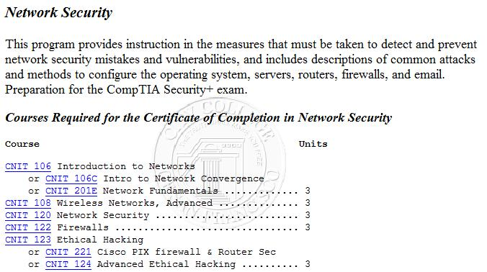

Associate of Science Degree
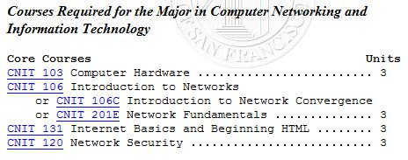

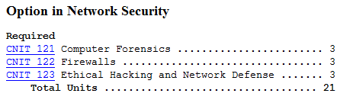

Equipment

Wireless Network Interface Cards (NICs) and Drivers

The Goal

All wireless NICs can connect to an Access Point

But hacking requires more than that, because we need to do

Sniffing – collecting traffic addressed to other devices

Injection – transmitting forged packets which will appear to be from other devices

Windows v. Linux

The best wireless hacking software is written in Linux

The Windows tools are inferior, and don't support packet injection

But all the wireless NICs are designed for Windows

And the drivers are written for Windows

Linux drivers are hard to find and confusing to install
Wireless Security

Three Security Settings

No security

WEP (Wired Equivalent Privacy)

Old and broken

Easily hacked

WPA and WPA2 (Wi-Fi Protected Access)

Very secure

The only significant vulnerability is to a dictionary attack, if the key is a common word

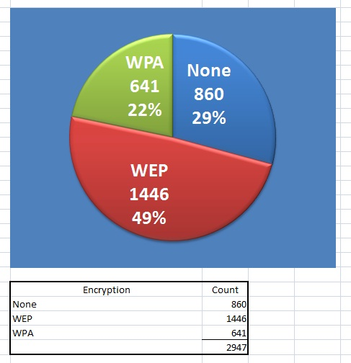
Wireless Security in San Francisco

Cracking WEP

Tools and Principles

A Simple WEP Crack

The Access Point and Client are using WEP encryption

The hacker device just listens

Listening is Slow

You need to capture 50,000 to 200,000 "interesting" packets to crack a 64-bit WEP key

The "interesting" packets are the ones containing Initialization Vectors (IVs)

Only about ¼ of the packets contain IVs

So you need 200,000 to 800,000 packets

It can take hours or days to capture that many packets

Packet Injection

A second hacker machine injects packets to create more "interesting packets"

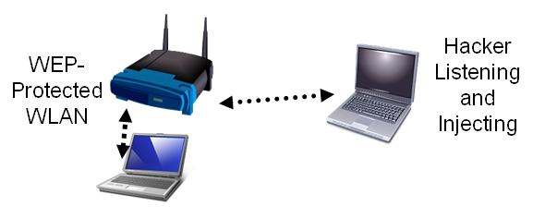

Injection is MUCH Faster

With packet injection, the listener can collect 200 IVs per second

5 – 10 minutes is usually enough to crack a 64-bit key

Cracking a 128-bit key takes an hour or so

Link l_14r

Cracking WEP

The Attack

Airodump

Sniffs packets to find networks

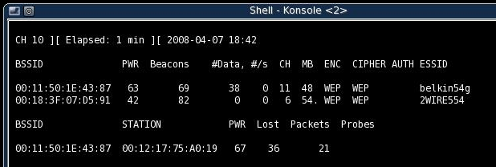

Aireplay

Finds an ARP packet and replays it to make cracking faster
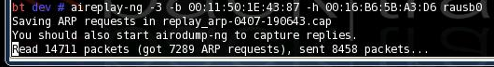

Data

This makes the #Data value go up much faster

We need at least 50,000 Data (IVs) to crack WEP

Aircrack

The captured IVs make the keyspace much smaller

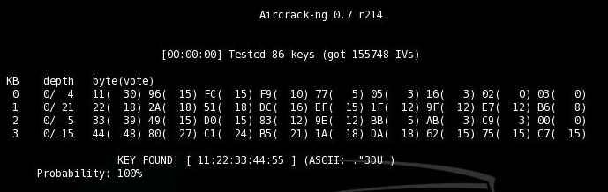
Aircrack performs a brute-force attack on all remaining keys

