What You Need for This Project
Warning: The USB Switchblade is really nasty—people can steal your passwords with it. Don't use it on any computer without permission, or even leave the hacked drive lying around. This is a really scary attack—don't be the victim or offender of anything unethical.
- Any Windows XP (not Vista) computer you have Administrator privileges on.
- A U3 USB flash drive without any data you need on it.
- Warning! This project will erase all the data on your USB flash drive, and you might have some difficulty restoring normal U3 functionality, in the worst case. .
Observing the Normal U3 Software Launch
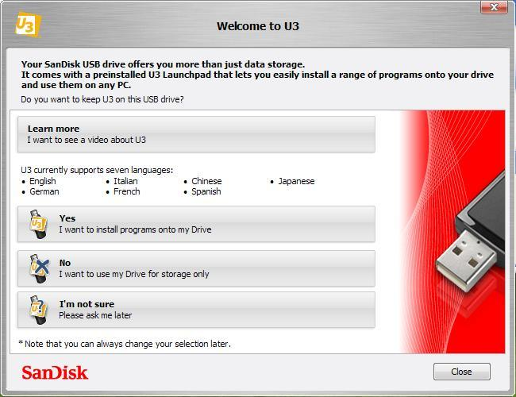
- Plug in the U3 Flash Drive.
- If you see a "Welcome to U3" box, as shown to the right on this page, click Yes, and in the "Welcome to U3 Software" box, click Close.
- If a "Welcome to U3" box appears, click Yes to enable the autorun, so you can install software on the U3 device.
- Look in the lower right corner of your desktop. You should see a square yellow U3 icon, as shown below on this page.


Downloading the PocketKnife and Universal Customizer
- Disable your virus scanner. The PocketKnife file DOES contain dangerous malware, of course. That's the whole point of the project—we are converting this innocent flash drive into a dangerous hacking tool. To disable the virus scanner, right-click the McAfee shield icon in the lower right corner of your desktop and click "Disable On-Access Scan", so the shield displays a red circle-and-slash over it, as shown to the right on this page.
- Open a Web browser and go to samsclass.info
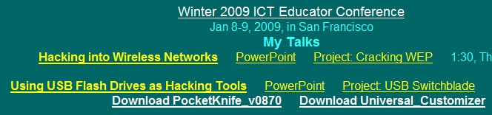
- Scroll down to the "Special Events" section, and find the "Winter 2009 ICT Educator Conference" section, as shown below on this page.

- Click the "Download PocketKnife_v0870" link. Save the file on your desktop.
- Click the "Download Universal Customizer" link. Save the file on your desktop.
- On your desktop, right click the PocketKnife_v0870.zip file and click "Extract All".
- In the "Select a Destination and Extract Files" box, accept the default location and click Extract.
- Repeat the process to extract Universal_Customizer.zip.
Copying the Flash Partition Files to the USB Flash Memory
- On your desktop, double click the PocketKnife_v0870 folder to open it. Double-click the Leapos_Payload_v0870 folder. Double-click the Leapos_Payload_U3 folder. Double-click the "Flash Partition" folder.

- You should see three folders and two files, as shown below on this page. Highlight all five objects, right click one of them, and click Copy.

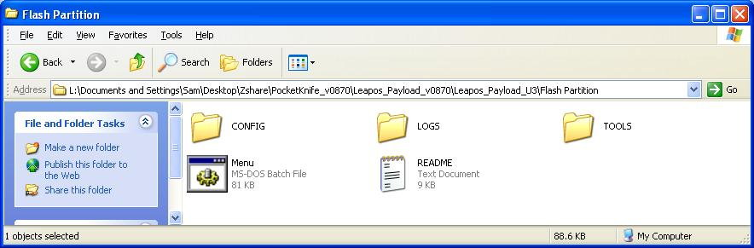
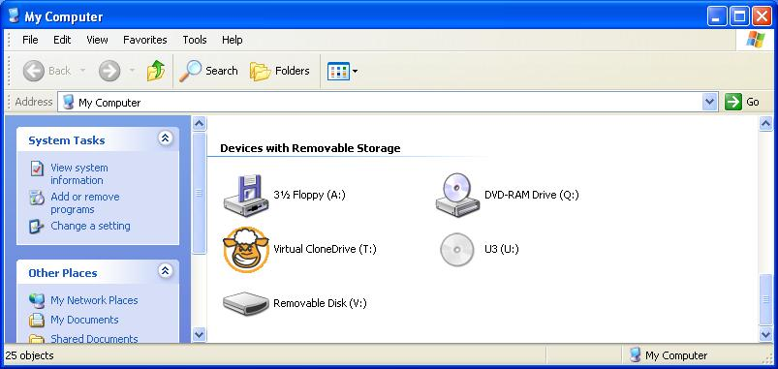
- Click Start, "My Computer". Find the "Removable Disk" volume, as shown to the right on this page, right-click it, and click Paste.

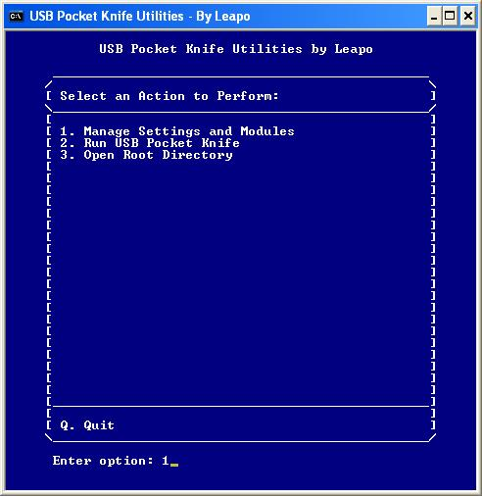
Selecting Payload Options
- In the "My Computer" window, double click "Removable Disk". Double-click Menu.bat.
- The Main Menu opens, as shown to the right on this page.
- From the Main Menu, type 1 to "Manage Settings or Modules" and then press Enter.
- In the next page, type 1 and press Enter, to "Enable or Disable Modules".
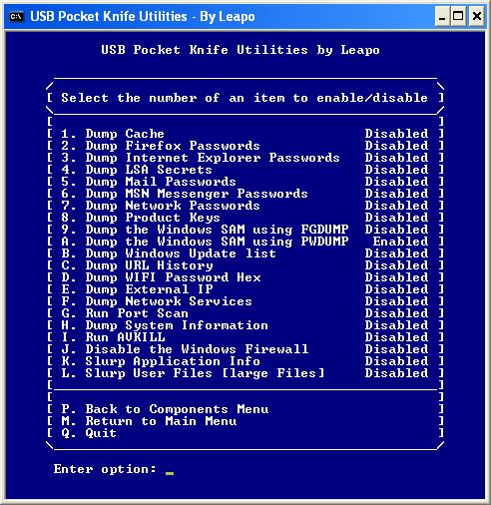
- The next screen lists all the modules included in the package.
- Type a and press Enter to enable Dumping the Windows SAM using PWDUMP, as shown to the right on this page.
- Type Q and press Enter, to quit.

Using the U3 Customizer to Install the PocketKnife Launcher
- On your desktop, double-click the PocketKnife_v0870 folder to open it. Double-click the Leapos_Payload_v0870 folder to open it. Double-click the Leapos_Payload_U3 folder to open it. Right click the U3.ISO file and click Rename. Change the filename to U3CUSTOM.ISO.
- Right click the U3CUSTOM.ISO file and click Copy.
- On your desktop, open the "Universal_Customizer" folder to open it. Double-click the BIN folder to open it. Right-click an empty portion of the folder and click Paste. In the "Confirm File Replace" box , click Yes.
- Return to the "Universal_Customizer" folder. Double-click the Universal_Customizer.exe icon . In the "Open File – Security Warning" box, click Run.
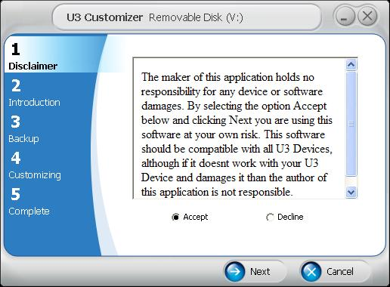
- The U3 Customizer opens, as shown to the right on this page. Click Accept and click Next.
- In step 2, click Next.
- In step 3, enter a password of password in both boxes and click Next.
- Wait while the progress bar moves in step 4. When the process is complete, click Next.
- At step 5, the process is done! Click Done.
- Unplug the U3 Flash Drive.
Stealing Password Hashes
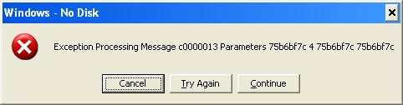
- Plug the drive back into your machine, or into any other Windows XP machine that is logged in with Administrative credentials.
- If you see an error message, as shown to the right on this page, click Continue. That's a bug in the PocketKnife software that happens on some systems, and the developers haven't solved it yet.
- After about 15 seconds, an Explorer window will pop up, showing the contents of the LOGS directory. There will be a folder with your machine's name on it, which should be something like S214-10. Double-click that folder to open it.
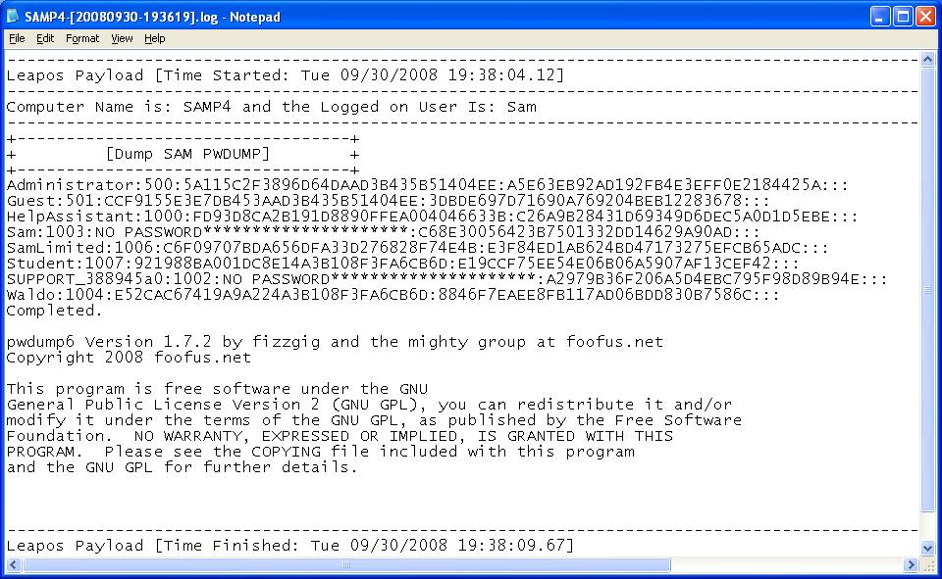
- Inside that folder is a text file with a long name, starting with your machine name. Double-click that file to open it in Notepad, as shown to the right on this page.

Using the U3 Launchpad Installer to Clean the Drive
- This is how you clean the drive to make it a normal USB drive again.
- Open a Web browser and go to http://www.sandisk.com/Retail/Default.aspx?CatID=1411
- Click the "Download Installer (.exe)" link. Save the installer on your desktop.
- Double-click the LPInstaller file on your desktop. In the "Open File – Security Warning" box, click Run.
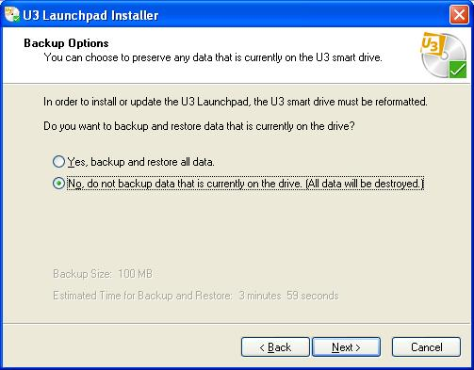
- In the "Welcome to th e U2 Launchpad Installer" box, click Next.
- In the "License Agreement" box, click Accept and click Next.
- In the "Backup Options" screen, click "No, do not backup…", as shown to the right on this page. Click Next.
- In the "U3 Launchpad installer" box, click OK.
- In the "Confirm Installation Options" box, click Next.
- In the "Launchpad Installation Completed" box, click Finish.

Sources
http://dotnetwizard.net/soft-apps/hack-u3-usb-smart-drive-to-become-ultimate-hack-tool/
http://www.phdcc.com/shellrun/autorun.htm
http://forums.gonzor228.com/index.php?topic=85.0
http://hak5.org/forums/index.php?showtopic=6746&mode=threaded&pid=71631
http://www.sandisk.com/Retail/Default.aspx?CatID=1411

PowerISO is the software that can image the U3 launchpad, as explained here:
http://www.u3community.com/viewtopic.php?p=4053&sid=d7502c2754eba11b19b17736c5425855

Last Modified: 1-8-08

