Start Your Vista Host Machine
- Your host machine should already be started. If it isn't, boot to Vista and log in as Student with no password.

Copying a Windows XP Virtual Machine to Your Vista Desktop
- Click Start, Computer. Double-click the VMs drive to open it. Double-click the Hacking folder to open it. Right-click the "Win XP Pro for Hacking" folder and click Copy.
- Right-click an empty portion of your desktop and click Paste. Wait until the copy is finished. This is your Windows XP Virtual Machine.

Starting your Windows XP Virtual Machine
- Click Start, "All Programs", VMware, "VMware Player". If you see a message about updates, click Close.
- In the "VMware Player" window, click the Open icon.
- In the "Open Virtual Machine" box, on the left side, click Desktop. Double-click the "Win XP Pro for Hacking" folder to open it. Double-click the "Windows XP Professional.vmx" icon.
- Windows XP starts in the VMware window. If it's not already logged in, click the Student icon to log in. No password is required.

Creating Passwords to Crack
- In the Windows XP Virtual Machine, click Start, right-click My Computer, and click Manage. In Computer Management, in the left pane, expand the Local Users and Groups container.
- In the left pane of Computer Management, click the Users container. You should see some accounts in the right pane, as shown below on this page.
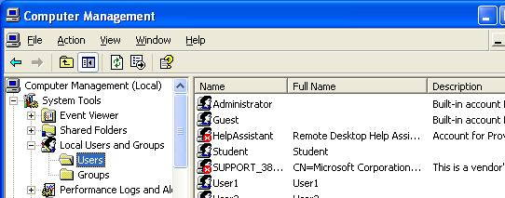

Creating Test Passwords
- Fill in the table below with passwords to test. Don’t just use my examples, which are very weak, scramble the letters and numbers to make passwords that are hard to remember and hard to guess. The only exception is Test15a – for that account, use the exact password I have given – fifteen a characters.

Testa6 Six letters like abcdef: _______________________________

Testa12 Twelve letters like abcdefghijkl: _______________________________

Testx A password you think is reasonably secure: _______________________________

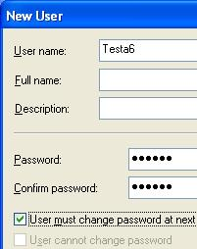
Creating Test Accounts
- In the left pane of Computer Management, right-click Users and click New User.
- In the NewUser box, enter user name of Testa6 and the password you wrote down above, and click Create. The check boxes in the lower section of the New User box don’t matter, because no one will really be using these accounts.
- Repeat the process to create all the accounts in the box above.

Shutting Down Your Virtual Machine
- In the Windows XP Virtual Machine, click Start, Turn Off Computer, Turn Off.

Setting the Virtual CD to Use the Physical CD
- Click Start, "All Programs", VMmanager, VMmanager.
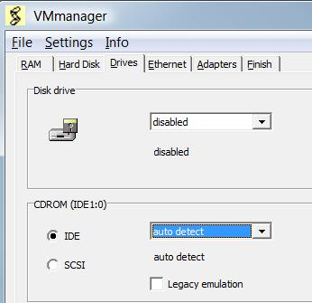
- In the VMmanager window, click the Modify button.
- In the Open box, on the left side, click Desktop. Double-click the "Win XP Pro for Hacking" folder to open it. Double-click the "Windows XP Professional.vmx" icon.
- In the VMmanager window, click the Drives tab. In the CDROM section, ensure that "auto detect" is selected, as shown to the right on this page.
- In the VMmanager window, click the Finish tab. Click the OK button. In the "VM Manager" box, click OK.

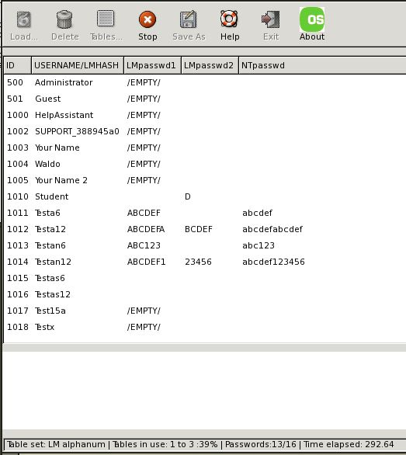
Booting from the Ophcrack CD Image
- Insert the Ophcrack CD into the CD drive.
- Click Start, "All Programs", VMware, "VMware Player". If you see a message about updates, click Close.
- In the "VMware Player" window, click the Open icon.
- In the "Open Virtual Machine" box, on the left side, click Desktop. Double-click the "Win XP Pro for Hacking" folder to open it. Double-click the "Windows XP Professional.vmx" icon.
- The virtual machine should boot from the CD. If it doesn’t, you may have to restart it, click in the blank window, press F2, and adjust the boot order in the BIOS.
- Ophcrack loads Slackware Linux and automatically runs the Ophcrack rainbow table cracker. A window should appear, with the user accounts listed, and passwords slowly filling in one-by-one as Ophcrack finds them.

Shutting Down Ophcrack and Restarting Windows XP
- Your virtual machine is still running Ophcrack. To stop it, right-click a blank part of the desktop and click Logout.
- When your virtual machine has shut down, remove the CD from the drive.

Restarting the Windows XP Virtual Machine
- Insert the Ophcrack CD into the CD drive.
- Click Start, "All Programs", VMware, "VMware Player". If you see a message about updates, click Close.
- In the "VMware Player" window, click the Open icon.
- In the "Open Virtual Machine" box, on the left side, click Desktop. Double-click the "Win XP Pro for Hacking" folder to open it. Double-click the "Windows XP Professional.vmx" icon.

Hardening Windows XP: Removing LM Hashes
- Click Start, Run. In the Run box, type this command, and then press the Enter key:
SECPOL.MSC
- "Control Panel". , "Administrative Tools"
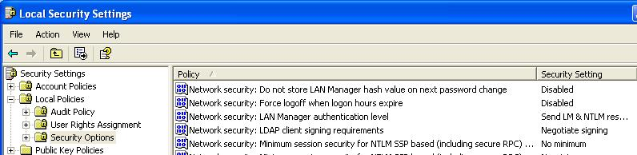
- In the "Local Security Settings" box, in the left pane, expand Local Policies, and then click Security Options, as shown below on this page.

- In the right pane, scroll down to find "Network security: Do not store LAN Manager hash value on next password change". Double-click that policy.
- In the "Network security: Do not store LAN Manager hash val…" box, click Enabled, and then click OK.
- Restart your virtual machine. Log in as Student.

Changing the Password for the Testa6 Account
- The change you just made will prevent LM Hashes from being created, but it will not remove the existing LM Hashes. So you need to change the passwords on any accounts you want to make secure.
- Click Start, right-click My Computer, and click Manage. In Computer Management, in the left pane, expand the Local Users and Groups container. Click the Users container to select it.
- Right-click the Testa6 account in the right pane and select Set password.
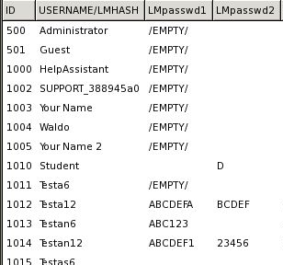
- In the Set password for Testa6 box, click Proceed.
- In the Set password for Testa6 box, enter a new password of any length in both boxes. Click OK.

Running Ophcrack Again
- Repeat the steps you did previously, under the heading “Booting from the Ophcrack CD Image.”
- You should see results as shown to the right on this page–the Testa6 account shows /EMPTY/ because there is no LM Hash and Ophcrack cannot crack its password.
Last Modified: 6-26-08

