Start Your Windows XP Machine
- Log on as Student with a password of password

Changing Your Password

Password: ______________________________
- Write a password to test in the box to the right on this page. Don't use your real password! Use any combination of uppercase letters, lowercase letters, and numbers, but not longer than 14 characters.
- Click Start, "Control Panel", "User Accounts", "User Accounts"
- In the "User Accounts" box, click the Student icon.
- In the "What do you want to change about Student's Account?" screen, click "Change the password".
- Change the password to the password you wrote in the box above on this page.

Insert the OphCrack CD
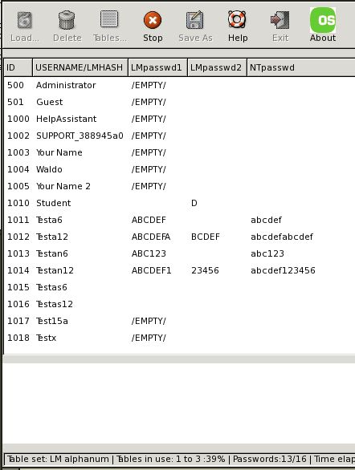
- Put the OphCrack CD into the CD-ROM drive.

Restarting the Computer
- Click Start, Turn Off Computer, Restart.

Finding the Password
- Ophcrack loads Slackware Linux and automatically runs the Ophcrack rainbow table cracker. A window should appear, with the user accounts listed, and passwords slowly filling in one-by-one as Ophcrack finds them.

Learning about LM Hashes
- Windows XP passwords are very insecure! With Ophcrack, anyone could easily crack almost any password of the usual length (8 characters or so). This is because Windows XP uses LM Hashes. To learn about LM Hashes, open a browser and read this brief article:
http://en.wikipedia.org/wiki/LM_hash

Shutting Down Ophcrack and Restarting Windows XP
- To stop Ophcrack, right-click a blank part of the desktop and click Logout.
- Restart the computer and eject the CD.
- Windows XP starts. Log in as Student with your the password you wrote in the box on the previous page.

Hardening Windows XP: Removing LM Hashes
- Click Start, "Control Panel", "Performance and Maintenance", "Administrative Tools".
- Double-click "Local Security Policy".
- In the "Local Security Policy" window, in the left pane, expand "Local Policies". Click "Security Options".
- In the right pane, scroll down to find "Network security: Do not store LAN Manager hash value on next password change", as shown below on this page.
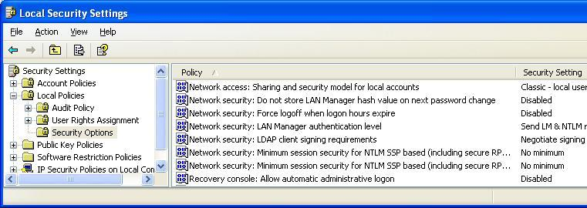
- Double-click "Network security: Do not store LAN Manager hash value on next password change". In the Properties sheet that opens, click Enabled and click OK.

Changing Your Password Again

Password: ______________________________
- Write a password to test in the box to the right on this page. Don't use your real password! Use any combination of uppercase letters, lowercase letters, and numbers, but not longer than 14 characters.
- Click Start, "Control Panel", "User Accounts", "User Accounts". In the "User Accounts" box, click the Student icon. In the "What do you want to change about Student's Account?" screen, click "Change the password".
- Change the password to the password you wrote in the box above on this page.

Running Ophcrack Again
- Repeat the steps you did previously, under the headings “Setting the Virtual CD to Use the Ophcrack CD Image” and “Booting from the Ophcrack CD Image.”
- The Student account should now show /EMPTY/ because there is no LM Hash and Ophcrack cannot crack its password. Notice that the unchanged passwords are still vulnerable, because the previously created LM Hashes are still present.

Using System Restore
- To prepare the machine for the next student, click Start, "Help and Support".
- In the "Pick a Task" section, click "Undo changes to your computer with System Restore".
- In the "System Restore" box, accept the default selection of "Restore my computer to an earlier time" and click Next.
- Click the restore point labeled "Ready for Projects".
- Click Next. Click Next again to perform the System Restore. When you are prompted to restart your machine, do so.

Last Modified: 12-2-08

