Sam Bowne
Computer Networking and Information Technology
City College San Francisco
Email: sbowne@ccsf.edu
Web: samsclass.info
Teaching Hacking

What do Hackers Do?

Get into computer systems without valid accounts and passwords

Open encrypted files without the key

Take over Web servers

Collect passwords from Internet traffic

Take over computers with remote access trojans

And much, much more

Ethical Hackers

Ethical Hackers do the same thing criminal hackers do, with one difference

Ethical Hackers have permission from the owner of the machines to hack in

These "Penetration Tests" reveal security problems so they can be fixed

CNIT 123: Ethical Hacking and Network Defense

Has been taught since Spring 2007 (four times)

Face-to-face and Online sections available Fall 2008

CNIT 124: Advanced Ethical Hacking

Taught for the first time in Spring 2008

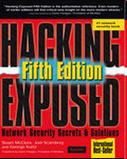
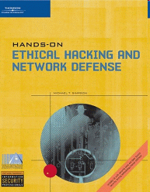

Supplemental Materials

Projects from recent research

Students get extra credit by attending conferences

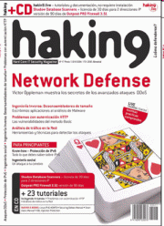




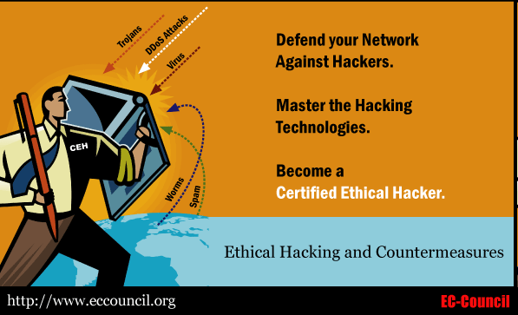

Certified Ethical Hacker

Those two classes prepare students for CEH Certification

Certificate in Network Security
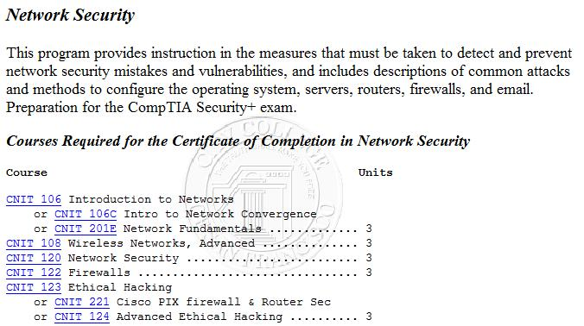

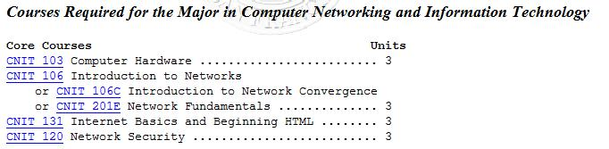
Associate of Science Degree

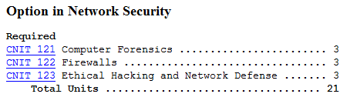

Windows Passwords

Password Hashes

Passwords are not stored on Windows computers in plaintext

They are run through one-way mathematical Hash Functions

Logging On

User types in password

Example: fish45

Windows calculates the hash

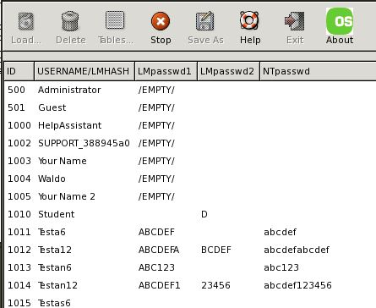
Example: 0Aa@!d88f8&7uO.?

The hash is compared to the stored password hash

If they match, the user is permitted to log on

LM Hashes

Windows breaks the password into two 7-character pieces

Each section is hashed separately

So a long, strong password like

Alligator1978

Becomes two short passwords

ALLIGAT OR1978

Weakness of LM Hashes

Each section has only 2⁴³ possible values

Modern computers can try all those values in just a few minutes

Ophcrack

Live CD – boot from it

Completely automatic LM Hash Cracker

Countermeasures

Hardening Windows

Microsoft has a stronger hashing technique called NTLM Hashes

But all versions of Windows before Vista use LM Hashes by default

A change in Local Security Policy can eliminate the LM Hashes (see references)
Cracking Vista

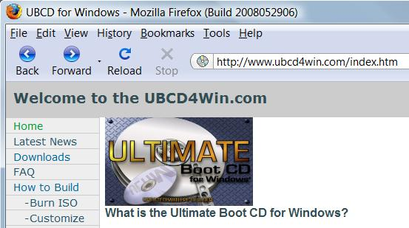
Ultimate Boot CD

With this CD, you can create new Administrator accounts on Windows XP, Vista, and Server 2008

It does not reveal existing passwords

References

Wikipedia: LM Hashes

http://en.wikipedia.org/wiki/LM_hash

Ophcrack LiveCD

http://ophcrack.sourceforge.net/

Ultimate Boot CD

http://www.ubcd4win.com/howto.htm

Turning off LM Hashes

http://support.microsoft.com/kb/299656 Last modified 6-26-08

