Network Setup
- Use Ethernet cables and a hub to connect the attacker and target computers together. This simple attack requires a hubbed network.
Installing Cain and Abel
- Open a Web browser. Go to http://www.oxid.it/cain.html
- Download Cain & Abel for Windows XP, install it. It will also install WinPCap.
Sniffing for Passwords
- Double-click the Cain icon on the desktop to launch Cain.
- In the upper left of the Cain window, click these three places, as shown below on this page:
  - The “Start/Stop Sniffer” button
  - The Sniffer tab in the top portion of the window
  - The Passwords tab in the bottom portion of the window
  - The HTTP Container on the left side
- Passwords appear in the center of the window
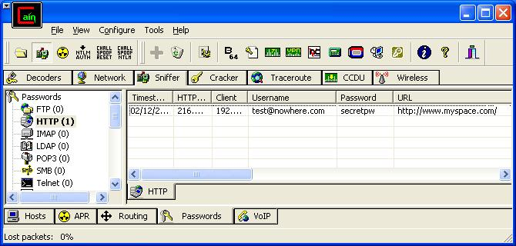
Start/Stop Sniffer
Sniffer
Tab
Passwords
Tab
HTTP
Container

Last modified 12-2-08

