What You Will Need
- A portable computer with Wi-Fi. The instructions below assume you are using a laptop or netbook running Windows 7, but students have also used Win XP, Linux, Macs, and even iPhones to wardrive.
- Wardriving software that records the encryption status of the access points. I recommend these programs:
For Windows 7: Vistumbler from vistumbler.net/
For Windows XP: InSSIDer from http://www.metageek.net/products/insider
For Linux: kismet
- These instructions assume you are using Windows 7. For other operating systems, you will have to figure out how to collect data and export it to a plain text file.

Downloading and Installing Vistumbler
- Open a Web browser and go to vistumbler.net
- Download the EXE and install it with the default options

Running Vistumbler
- Click Start, type in VIS, and click Vistumbler. If you see a User Account Control box, allow the software to make changes to your computer.
- In the Visstumbler window, click the "Scan APs" button. You should see some wireless networks detected, as shown below on this page. If you don't, you may need to move to a location where there are Wi-Fi networks, such as the CCSF campus. If you still see no networks, click Interface and make sure it’s using your wireless adapter.
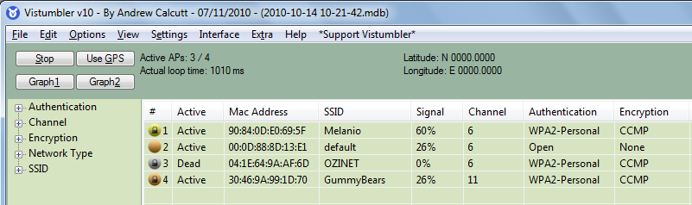

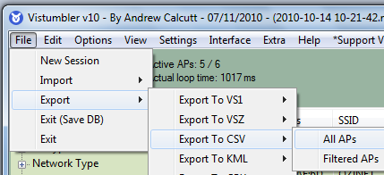

Saving the Data
- In Vistumbler, click File, Export, "Export to CSV", "All APs", as shown to the right on this page.

- In the "Export to CSV" box, enter any name. Accept the default selection of Summary. Click the OK button.
- In the "Done" box. click OK.
Opening the File in Excel
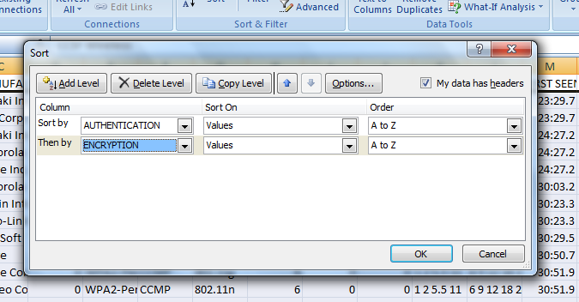
- Click Start, Computer. Navigate to C:\Program Files\Vistumbler\Save. Right-click the YourNameWardrive.csv file, click "Open with…", and select Excel.
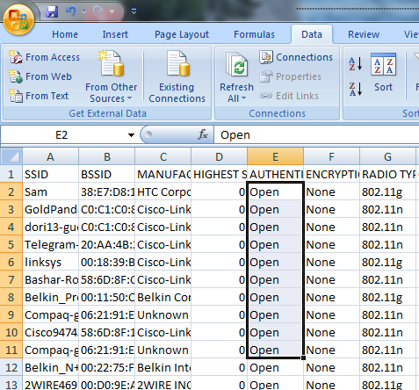
- Press Ctrl+A to select all the data
- On the Data ribbon, click Sort. In the Sort box, click the Add Level button. Sort by AUTHENTICATION and Then by ENCRYPTION, as shown above. Click OK.
- In the AUTHENTICATION column, click the top “Open” (in row 2). Hold down the Shift key and press the Down-Arrow key to highlight the “Open” cells, as shown to the right.
- Continue highlighting cells until you have highlighted all the OPEN cells that have ENCRYPTION set to “None”, as shown below. You may use the PgDn key to move down faster. When you have them all highlighted, look in the lower right corner to see the Count. Write down that number.
- Repeat the process to determine how many networks were in the four categories: None, WEP, WPA, WPA2. Also record the TOTAL.
Last modified 4-25-14
